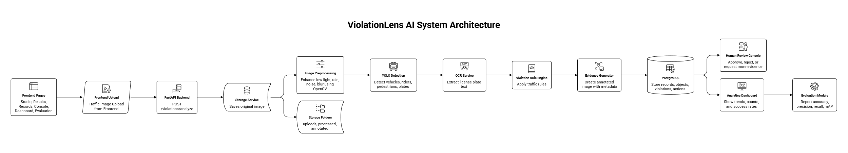
GitHub Repository: https://github.com/PralayaRanjan/violation-lens-ai
Live Prototype: https://violation-lens-ai.vercel.app/

